**Project 02: Onboard LED Flashing**

## Project 1: Onboard LED Flashing

**1. Description：**

There is an onboard LED in Raspberry Pi Pico,which is a GP25 pin attached to the Raspberry Pi Pico. In this project, we will learn the effect of making the onboard LED blink.

**2. Components**

|  |  |
| --- | --- |
| IMG_256 |  |
| Raspberry Pi Pico\*1 | USB Cable\*1 |

1. **Wiring up**

In this project, Raspberry Pi Pico is connected to a computer using a USB cable.

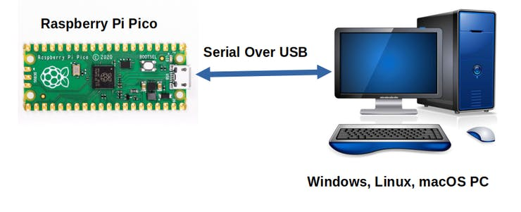

1. Test Code：

The onboard LED of Raspberry Pi Pico is controlled by GP25. When the GP25 outputs high, the LED will be on; when outputting LOW, the LED will be off.

You can open the code we provide:

Go to the folder KS3020 Keyestudio Raspberry Pi Pico Learning Kit Ultimate Edition\2. Windows System\2. C\_Tutorial\2. Projects\Project 02: Onboard LED flashing\Project\_02\_Onboard\_LED\_Flashing.

|  |
| --- |
| //\*\*\*\*\*\*\*\*\*\*\*\*\*\*\*\*\*\*\*\*\*\*\*\*\*\*\*\*\*\*\*\*\*\*\*\*\*\*\*\*\*\*\*\*\*\*\*\*\*\*\*\*\*\*\*\*\*\*\*\*\*\*\*\*\*\*\*\*\*\*  /\*  \* Filename : Onboard LED flashing  \* Description : Make an led blinking.  \* Auther : http//www.keyestudio.com  \*/  #define LED\_BUILTIN 25  // the setup function runs once when you press reset or power the board  void setup() {  // initialize digital pin LED\_BUILTIN as an output.  pinMode(LED\_BUILTIN, OUTPUT);  }  // the loop function runs over and over again forever  void loop() {  digitalWrite(LED\_BUILTIN, HIGH); // turn the LED on (HIGH is the voltage level)  delay(1000); // wait for a second  digitalWrite(LED\_BUILTIN, LOW); // turn the LED off by making the voltage LOW  delay(1000); // wait for a second  }  //\*\*\*\*\*\*\*\*\*\*\*\*\*\*\*\*\*\*\*\*\*\*\*\*\*\*\*\*\*\*\*\*\*\*\*\*\*\*\*\*\*\*\*\*\*\*\*\*\*\*\*\*\*\*\*\*\*\*\*\*\*\*\*\*\*\*\*\*\*\*\*\*\*\*\*\*\*\*\*\*\*\*\*\*\* |

Before uploading Test Code to Raspberry Pi Pico, please check the configuration of Arduino IDE.

Click "Tools" to confirm that the board type and ports.

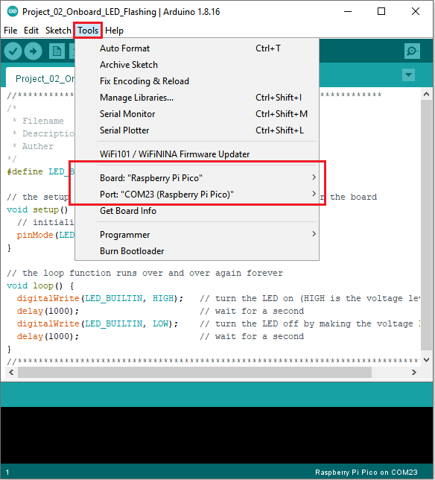

Click  to upload the test code to the Raspberry Pi Pico board

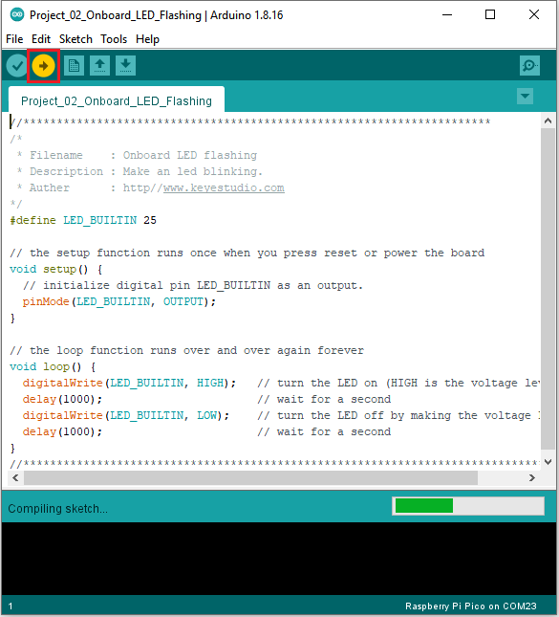

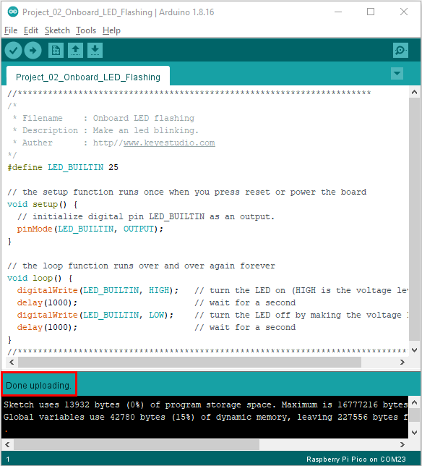

**5. Test Result**

After the project code was uploaded successfully, the LED of Raspberry Pi Pico started flashing

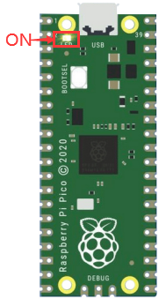 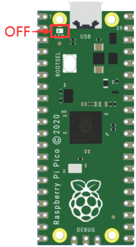

1S